Ways to Improve a Map Visualization
How to take a map visualization to the next level.
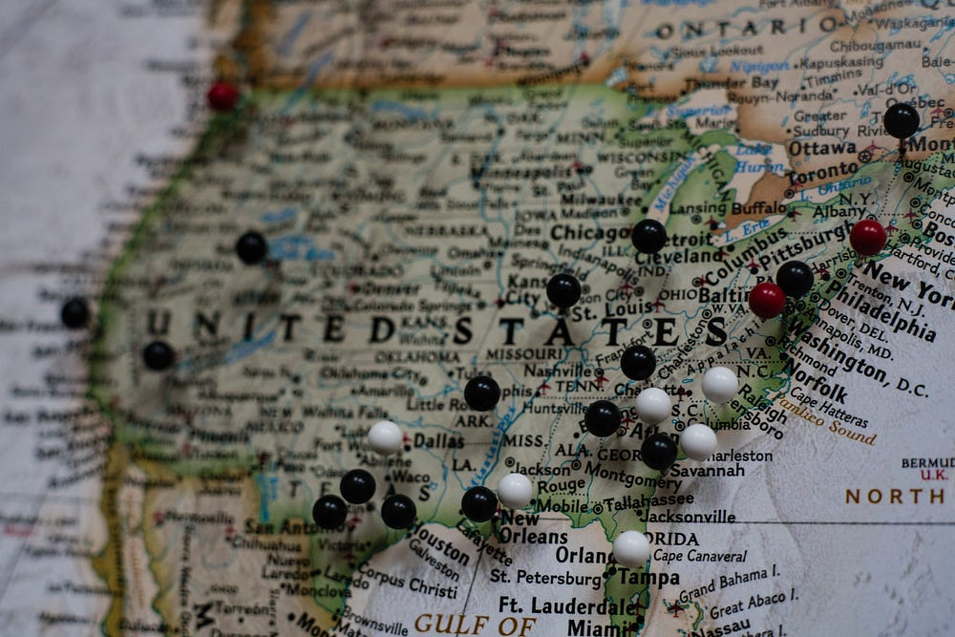
Photo by Joey Csunyo on Unsplash
First, I will cover two reasons why visualizing data using maps is often compelling to an audience. Then, I will cover three tips that will help you make the transition from good to exceptional when building map visualizations.
Why Use a Map for a Data Visualization?
It will provide important context to your data.
Let’s start with a hypothetical scenario. It’s your first week on the job and you have been tasked with presenting monthly sales results to the owner of your company. Ron in finance will send you the data and you will put together some slides. Should be a piece of cake. What if you opened up the data file and there was only one number?
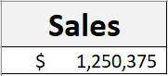
Personally, I would hope that Ron in finance was playing some sort of hilarious joke on the new hire. Have you figured out where I am going? Data needs context in order to provide value to the audience. Are sales up or down from prior month? Who are our top sales representatives? How will sales revenue tie into profit? No matter how nice the owner of your company is — if this is the only thing you brought to the meeting it would probably not go well.
Remember those Five Ws? Who, What, Where, When, and Why. This list was created to help journalists figure out the important context on a subject before crafting the story. It works because they are the things the audience would like to know too. Being a journalist and communicating with data are not much different in this sense. Before you craft a data story try plotting the data out on a map. This can quickly solve for where.
Starting at a young age, we have all been exposed to geographical concepts.
Data visualization designer, Ryan Sleeper, writes in his book Practical Tableau, “The power of maps comes from their inherent ability to leverage schemas that your users have been building up for many years.”
This is an enormous advantage in that map visualizations can be quickly interpreted by the audience. Less effort on understanding the visualization design allows for more focus on what the data in the visualization is saying. How long does it take you to decode the first picture vs the second?
Press enter or click to view image in full size
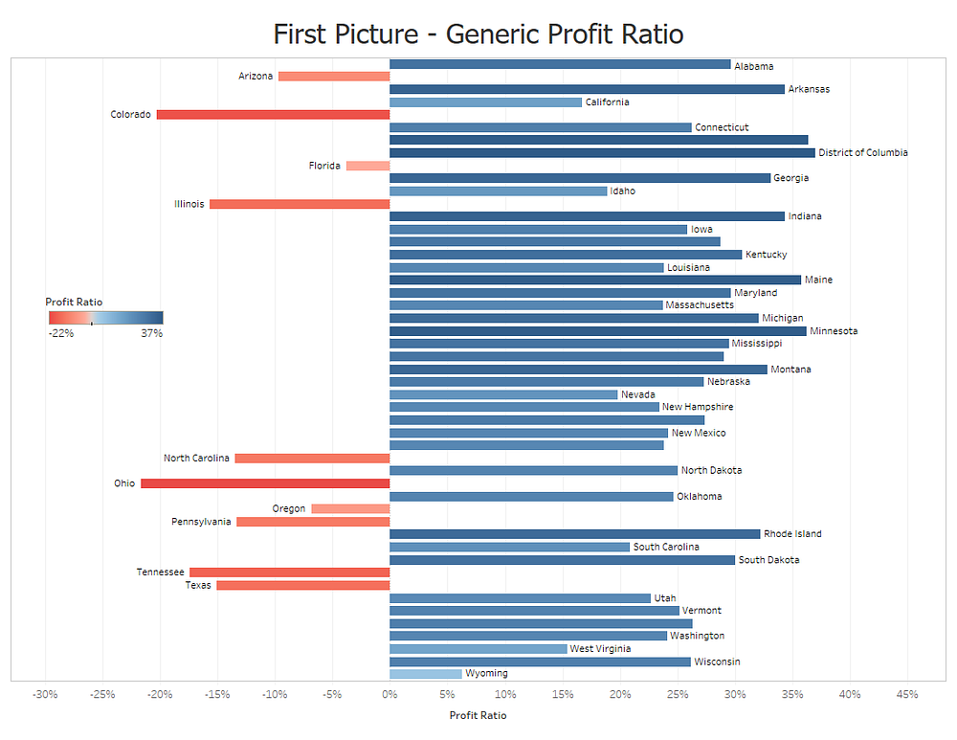
Visualization: Shelby Temple, made with Tableau; data: Tableau Sample Superstore
Press enter or click to view image in full size
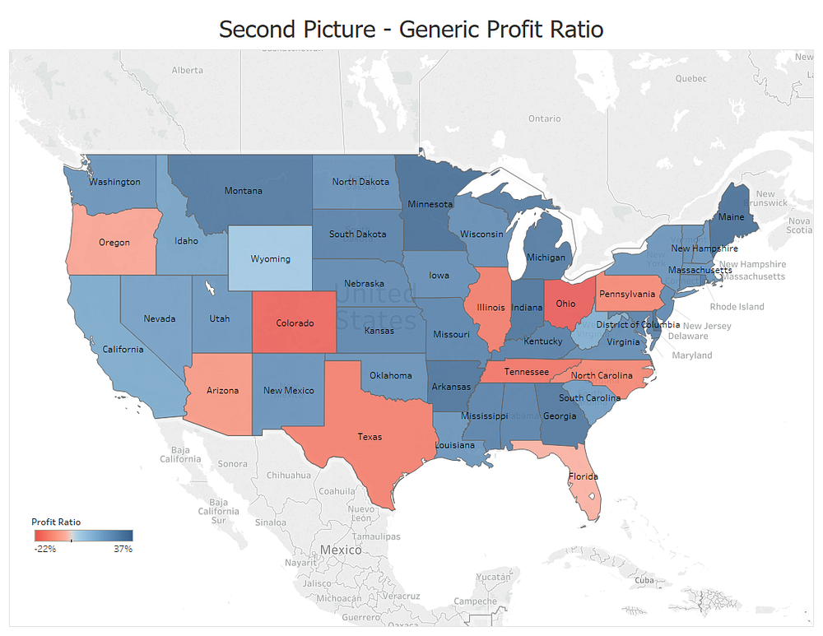
Visualization: Shelby Temple, made with Tableau; data: Tableau Sample Superstore
There are many more reasons to bring geography into your data visualization but I feel that this is enough to agree that this type of visual has significant advantages. As promised, let’s jump into some tips on how to take your map visualization to the next level.
1. Use Viridis or Magma Color Palettes
When selecting colors for data visualization I’ve noticed people are often selecting the colors that appeal the most to them. Unfortunately, this is not the best approach — because what appeals to you might not be appealing to someone else.
A data visualization needs to have colors that will best resonate with the audience. In addition, it should lead to quick and accurate decisions. Using certain color palettes (such as Jet, the old default for Python package Matplotlib) were found to lead to slower and inaccurate decision making.
No need to worry, Nathaniel Smith and Stefan van der Walt have already created open source palettes that are colorful, pretty, accessible to colorblind viewers, and now research backed to be effective color palettes for quick and accurate decision making.
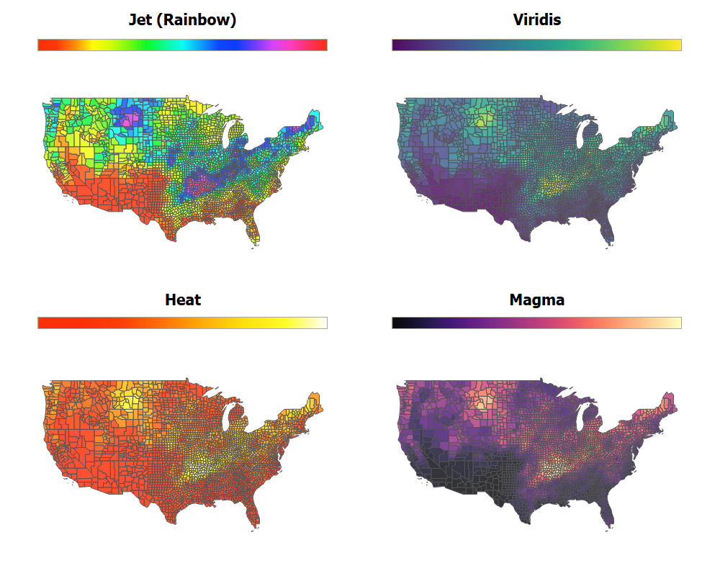
Visualization: Shelby Temple, made with Tableau; Inspired by work of Jacob Olsufka; Data: Temperature data from MarkieAnn Packer
Jet suffers from not being perceptually uniform or color blind friendly. Heat under indexes on range of colors and washes out easily.
If you want to learn more about color theory and the development of Viridis this video from the creators is both entertaining and informative.
Also, here is an article where Viridis was tested against other common color palettes and performed well for both speed and decision accuracy.
A quick thank you to Ben Jones who’s Tweet originally brought these color palettes to my attention.
2. Use Hex Tile Grid Maps
Hex tile grid maps were recently created as an improvement to the tile grid map. Tile grid maps were created to deal with issues such as trying to create a map of the US with Alaska and Rhode Island. Where Alaska demands too much visual real estate and Rhode Island often gets lost. Here I am plotting out average tornado track length by state.
Press enter or click to view image in full size
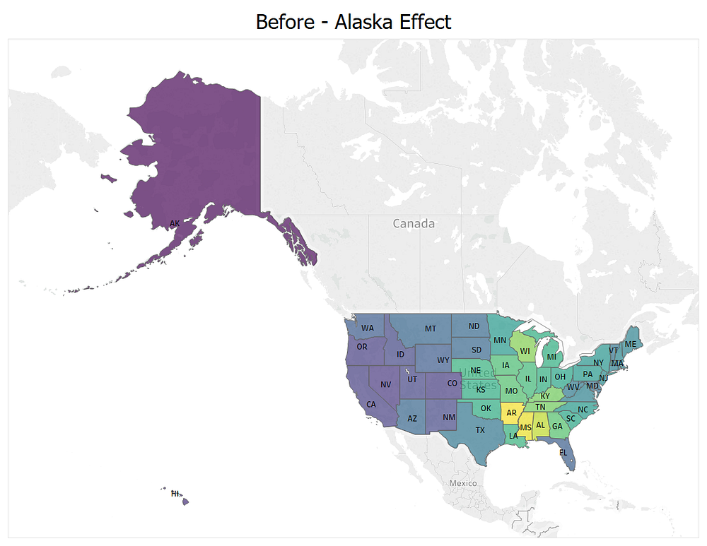
Visualization: Shelby Temple, made with Tableau; data: https://www.ncdc.noaa.gov/stormevents/
Press enter or click to view image in full size
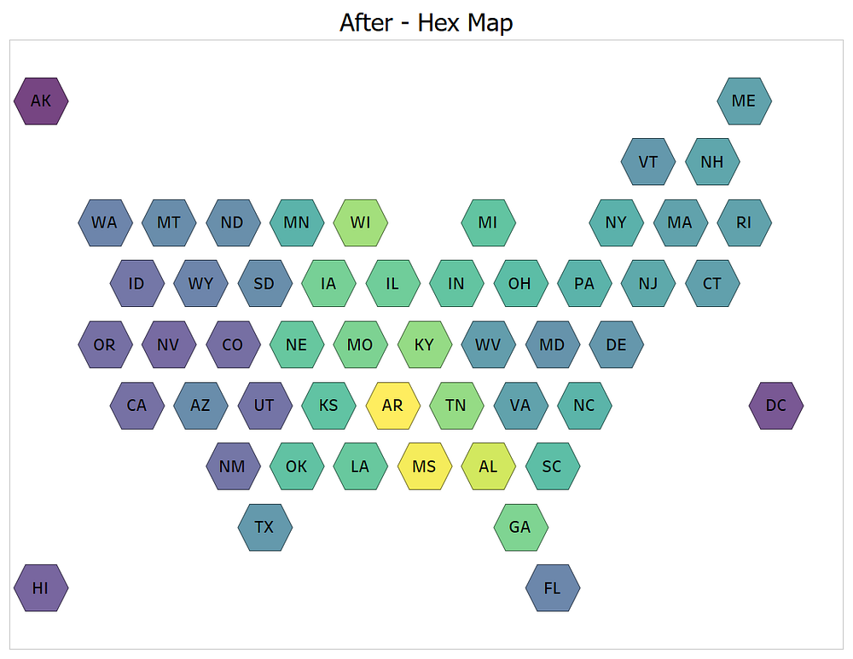
Visualization: Shelby Temple, made with Tableau; Inspired by work of Matt Chambers; data: https://www.ncdc.noaa.gov/stormevents/
These maps are much like the United States’ Senate, where every region gets equal (visual) representation. Rhode Island is now the same size as Alaska, but the positioning still allows the audience to understand they are looking at a map visualization of the US.
The hex grid map improves on the tile map by allowing for more adjacent shapes that are the same distance away. The distance from the center of a square tile is only the same for up, down, left, and right. The diagonal square tiles have centers that are farther away. In a hex grid map, you can fit together more tiles increasing the directional accuracy of the map.
I have traced the creation of the hex grid map as a data visualization through Matt Chambers (who made it in Tableau) to Danny DeBellus, Alyson Hurt, and Brian Boyer who were working in data journalism for NPR in 2015. Here is that article.
3. Drop the Borders and Go with Density
Country, State, City, and Zip Code are great in that they provide a consistent hierarchical way to explore data by geography.
However, many spatial phenomenon don’t confine to these human-made boundaries. Does a house robber reach the boundary of a zip code, shrug, and say, “Welp! I guess it’s time to turn around.” — Probably not.
Like robbers, tornadoes also do not care about zip codes. This makes it a great candidate for a density heat map.
Press enter or click to view image in full size
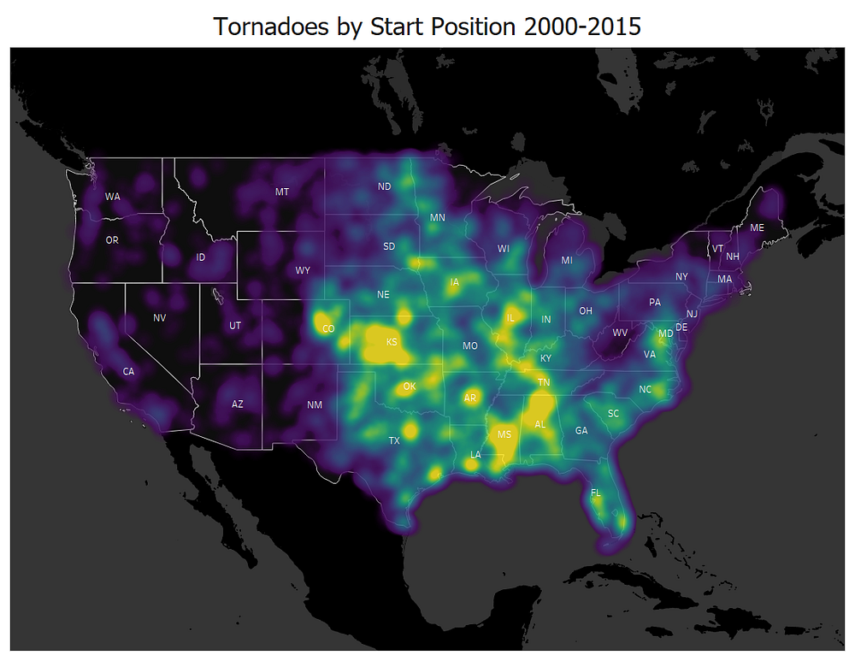
Visualization: Shelby Temple, made with Tableau; data: https://www.ncdc.noaa.gov/stormevents/
Density maps visualize data by clusters. This allows for a true understanding of any emerging patterns because they are not confined to imaginary human-made boundaries.
A common example where I see this issue occur is looking at data by state. St. Louis is on the border of Illinois (IL) and Missouri (MO). Looking at your data by state will cut this large metro in half and any patterns or trends in that area could be lost.
Conclusion
These are my favorite ways to improve a map. If you are looking for more I suggest checking out bivariate choropleths, using distance or radius filters, and normalizing the data for population.
Leaving you with one last map to enjoy!

